Activity:In a group of 3 – rotate making direct-indirect-answerA: Direct question: What did you do last night?B: Change to indirect question: Can you tell me what you did last night?C: Answer: I played play station last night.C: Direct question: …

What did you do this morning?  
Can you tell me what you did this morning?  
I played computer games this morning.

Getting a Job

What do these people do? Write a short description of their job.

Webmaster Responsible for building, managing, and updating a company’s website.

Help-desk troubleshooter Support and technical assistance for customers.

Applications programmer Responsible for developing, testing, and writing program documentation.

Security specialist Designing and managing computer security; e.g. anti-virus, firewalls, employee training.

Systems programmer Installs and maintains the operation system. Responsible for installing/upgrading sofrware.

Complete the table:

|  |  |  |  |
| --- | --- | --- | --- |
| 1. Job Title 2. Nature of work 3. Formal qualifications 4. Personal qualities 5. Technical skills 6. How to get started 7. How to make progress | **A**  programmer  Make program  work history  good memory, attention to detail, logical mind  logical mind  read a lot of  programming magazines, programming training | **B**  **1. Computer Consultant**  **2. Consultanting program**  **3. .**  **4. university degree**  **5. understanding** | **C**   1. **IT managers** 2. **manage projects, technology, and people.** 3. **five years’ experience, good knowledge of hardware and software.** 4. **Positive, friendly personality, lead others** 5. **Software developing** |

A.

The main requirements for being a good programmer are good memory, attention to detail, and a logical mind. You should also be a good problem solver, able to break a problem down into smaller tasks.But you need more than a logical mind to get a job. An employer will want to see some formal qualifications and a work history. It is best if you can show an employer a piece of software that you have made.The best way to start is to read a lot of programming magazines, do a lot of programming in your free time, and take some training courses.

B.

To be a good computer consultant you can’t know everything but you must have a good general understanding of a lot of things in IT. Consultants usually work for a short time - a few days or a week - for a few companies that keep giving them work again and again.Qualifications are important but don’t just rely on your university degree. You also need to take some training courses because these are very useful.Here’s how to progress in this job. After leaving university, get a technical job and spend your weekends and evenings taking courses. (Hopefully your employer will pay for these!) Change companies after a couple of years to get more experience. After this, you should be ready to try to get a job in a consulting company. Finally, you might be able to start your own consultancy business.

C.

IT managers manage projects, technology, and people. You will be responsible for making sure everyone’s computer is working, maintaining the servers, installing new software, and running the help-desk. You could also be responsible for developing and maintaining software for the company.An IT manager needs more than five years’ experience in the field and a good knowledge of hardware and software. They are usually between 30 and 45 years old.You need to have a positive, friendly personality and be someone who can lead others well. These skills usually can’t be taught, so technical qualifications are usually less important.

Which careers match these statements?:

1. You may only work for a few days for one company. Consultant
2. You should buy books on languages, e.g. Python. Programmer
3. You may be responsible for developing software for the company. Programmer/IT manager
4. You should be able to break down a problem into smaller tasks. Programmer
5. You should take training courses. Programmer/Consultant
6. You should try to become self-employed. Consultant
7. You need to have a positive, friendly personality. IT manager

|  |  |
| --- | --- |
| Language: **need to, have to, must, be + essential/critical** | |
| Positive:  You **need to** be able to work well with others.  IT managers **have to** work hard.  You **must** have at least 3 years’ experience.  Experience with Java **is essential/critical**.  You must have experience whit Java. | Negative:  You **don’t need to** have a degree in computing.  You **don’t have to** be an expert in everything.  You **must not** use the computer for personal projects. |

Fill in the Blanks:

1. Some technical qualifications have/need to be renewed every 2 years.
2. You don’t need to/have to know every programming language.
3. You must/need to/have to have good communication skills to be a manager.
4. You don’t need to/have to be an expert in hardware to become a programmer.
5. You must/need to/have to have worked with IBM mainframes for at least one year.
6. You must/need to/have to be able to show leadership.
7. You must/need to/have to have a degree and it needs/has to be in computing science.
8. You need/have to have experience with JavaScript.
9. Experience with Python is essential/critical these days. = You must have experience with Python.





1. Personal Information
2. Work Experience / Job History / Work History
3. Position Held / Job title
4. Main activies and responsibilities / Duties
5. Education and Training
6. Title of qualification awarded
7. Subjects/Occupational skills covered
8. Personal skills
9. Organisational skills
10. Technical skills

|  |  |
| --- | --- |
| Webmaster   * Strong Unix experience * Able to use JavaScript and Python * Knowledge of Shell Scripts | Systems Manager   * Technical specialist * Min. 2 years experience * Computer science degree not required |



**Mid-Term Exam Grammar Review**

Indirect Questions:

Change the following to indirect questions:

1. Why did you install it there?
2. Where are you going?
3. Is it easy to use?
4. Where does he live?

Change the following to direct questions:

1. Could you tell me how to do the project?
2. Can you explain why it is broken?
3. I wonder if he made that program.

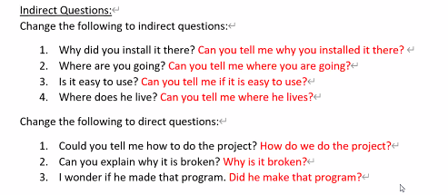

Necessity:

We are looking for a systems manager to work for our company. The following are the job requirements:

* Technical specialist
* Minimum 2 years’ experience
* Computer science degree not required
* Strong writing skills

Look at the job advertisement and write four sentences using the prompts:

1. (must) _________________________________
2. (need to) _________________________________
3. (have to) _________________________________
4. (essential) _________________________________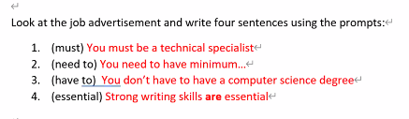

Adverbs of Frequency:

Complete the sentences with an appropriate adverb of frequency

1. He lives next door, so I _______ see him.
2. Nancy and I _____ (30%) go out for coffee.
3. It _____ (2%) rains here in the summer.
4. I have a meeting with my manager ______

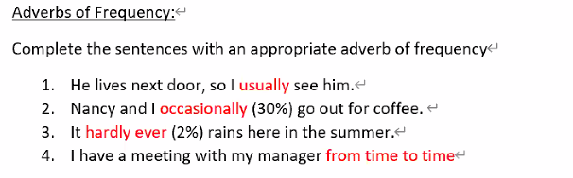

Articles:

I have ____ big assignment due tomorrow. ___ assignment is to imagine I am applying to ____ company for a job and I have to make ____ resume. ___ professor said that ____ resume must look professional, so I looked online to find ____ example of a nice-looking resume.

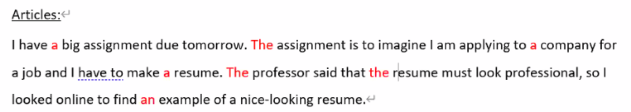

Crossword

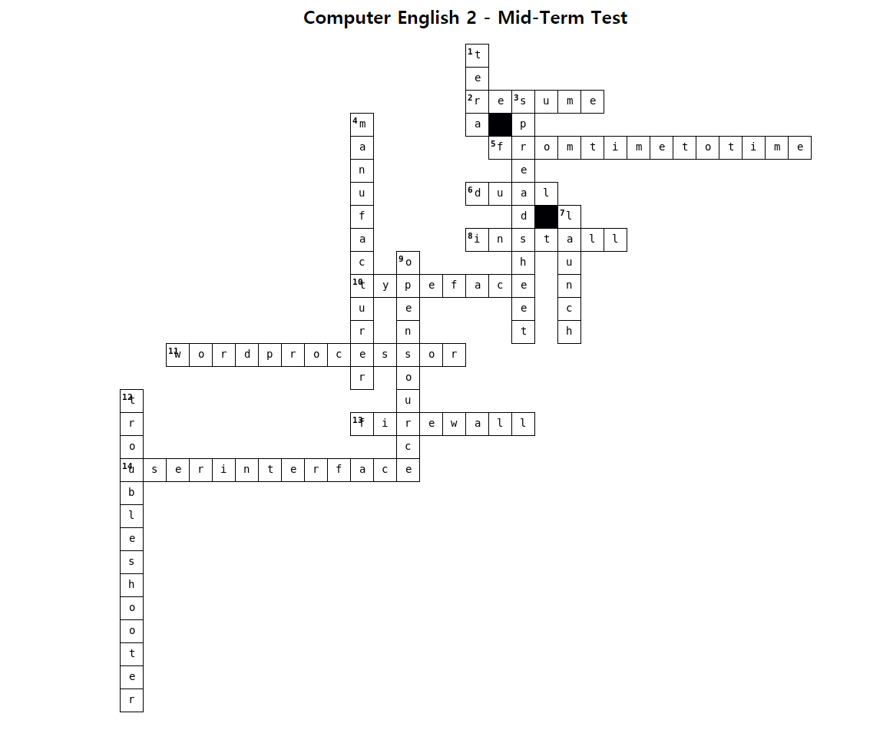

**Indirect Questions:**

Direct question : Where is the USB port?

Indirect question : Could you tell me where the USB port is? – softer / more polite

Indirect question phrases:

Could you tell me ..

Could you explain …

Do you know …

I wonder …

Question word pattern:

Is/Are: Indirect question phrases + question word + sentence (S + is/are)

Do/Did/Does: Indirect question phrases + question word + sentence (do/dis/does X)

|  |  |
| --- | --- |
| Why are you happy?  How fast is the CPU?  When ~~do~~ you play soccer?  When  ~~does~~ she play soccer? | Could you explain why you are happy?  Could you tell me how fast the CPU is?  I wonder when you play soccer?  Do you know when she play**s** soccer? |

Yes/No question pattern: (same as above but include ‘if’)

Is/Are: Indirect question phrases + If + sentence (S + is/are)

Do/Did/Does: Indirect question phrases + If+ sentence (do/dis/does X)

|  |  |
| --- | --- |
| Is your friend happy?  Do they study hard?  Does she study hard? | Do you know if your friend is happy?  I wonder if they study hard?  I wonder if she stud**ies(3인칭)** hard? |

Write indirect questions:

1. Where’s the station? Could you tell me where the station?
2. Are you coming to the party? Could you tell me if you are coming to the party?
3. How does it work? Could you tell me how it works?
4. What are you doing? Could you tell me what you are doing?
5. Does Annie know how to install a file? Could you tell me if Annie know**s** how to install a file?
6. Have you checked for viruses? Could you tell me if you have checked for viruses?
7. Is the printer connected? Could you tell me if the printer is connected?
8. Is it turned on? Could you tell me if it is turned on?
9. How do I save the file? Could you tell me how I save the file?

**IT Systems**

Internal Component (I) or Peripheral (P) or Storage (S)

|  |  |  |
| --- | --- | --- |
| External drive S/P  Hard disk drive S/I  Headphones P  Optical disc drive S/P/I | Keyboard P  Solid state drive S/I/P  Mouse P  Memory S/I | Monitor P  Power supply unit I  Printer P  Screen P |

Listen and label

|  |  |  |
| --- | --- | --- |
| 1. Audio socket E  2. CPU socket A  3. DIMM slot B | 4. Ethernet connector F  5. Graphics card socket D  6. SATA socket C | 7. USB port G |

Match the prefixes to the numbers:

|  |
| --- |
| dual- giga- kilo- mega- micro- milli- nano- quad- tera- |

|  |  |  |
| --- | --- | --- |
| 1,000,000,000,000 tera  1,000,000,000 giga  1,000,000 mega | 1,000 kilo  0.000000001 nano  0.000001 micro | 0.001 milli  4 ­quad  2 dual |

Listen to an IT manager and assistant talking about a problem with a delivery. Correct the information:



1. **1 x 300 => 1 x 500 GB SDD**
2. **8 => 16GB**
3. **1920 x 1080 => 1366 x 768**
4. **Quad => 8-core**

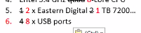

**IT Support**

Read and complete:



1. Switched
2. Type
3. Worked
4. Checked
5. Tight
6. Found
7. Unplugged
8. Go
9. Worked
10. disconnected

Write expressions to match the problem (Use the words in brackets):

|  |  |
| --- | --- |
| My internet is slow  My password won’t work  Her laptop wont’ work  His printer won’t work  Their printer won’t work | (check / viruses) Check for viruses (imperative)  (changed / password) Have you changed your password? (have + p.p)  (charge / battery) She need**s** to charge her laptop batteries (need to)  (plug in / printer) Make sure he has plugged in the printer (make sure)  (update / drivers) They should update their drivers (should) |

You are a helpdesk technician. Listen to three phone calls and complete the help desk tickets:

|  |  |  |
| --- | --- | --- |
| Date:  Name:  Problem:  Contact:  Service Person: | Date:  Name:  Problem:  Contact:  Service Person: | Date:  Name:  Problem:  Contact:  Service Person: |

Now complete the service reports for the IT Support Team. Use the information in the tickets and the words in the box:

|  |  |
| --- | --- |
| Service Report | |
| Date | 6.05 |
| Name | Bolek |
| Fault Diagnosis Questions | 1. _____________________ do you have?  2. ____________________________ |
| Possible Solutions | 1. If you have newer version, ______________  2. Ask the sender to save the file in an older version and ___________ |

|  |  |
| --- | --- |
| Service Report | |
| Date | 17.06 |
| Name | Sara |
| Fault Diagnosis Questions | 1. _______________________  2. Are there any messages about _______________ |
| Possible Solutions | 1. _________ the attachment changes.  2. Look for the file in ________________ |

|  |  |
| --- | --- |
| Service Report | |
| Date | 14.07 |
| Name | Sylvia |
| Fault Diagnosis Questions | 1. _______________________  2. Have you checked ________________  3. Have you run the ___________________ |
| Possible Solutions | 1. If the file is in the Recycle bin, move it to _________________  2. If the file isn’t in the Recycle bin, _______________________ |



Getting a Job

Read the following job advertisement and complete:



1. Supplies / provide
2. Service centers
3. Provide
4. Spreadsheet and database
5. Launched
6. Client
7. Installing / Maintaining
8. Maintaining/Installing
9. Diagnosing
10. From time to time

[활동]

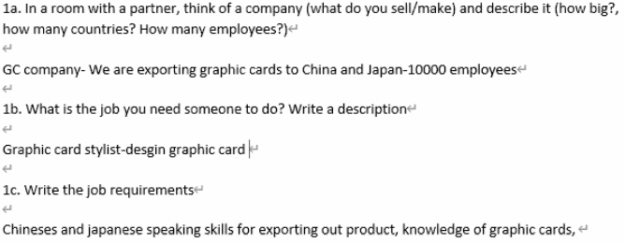

Open Source Software

|  |
| --- |
| spreadsheets one stores operating free processors secret  proprietary software design vendors features |

With open source software, what do people think about first? Money, usually, because open source software is free But this isn’t the only important thing. First, there is freedom from the software vendors. Organisations say that freedom is the number one reason to choose open source software. With open source software, an organisation doesn’t have to follow the software vendor’s decisions. With proprietary software the vendor controls software updates. For example, users can’t add features to proprietary software themselves but they can add features to open source software.

Also with open source software companies have more control of their data. Proprietary software often stores data in special ways that only the vendor understands. So, when a company wants to change to another vendor’s software, moving the data to the new software can be very difficult. Open source software is different; open source software vendors explain their data clearly and openly so that they are not a secret. Because of this, moving data isn’t a problem.

Sometimes people worry about open source operating systems. They think that their favourite software won’t run on open source operating systems. However, this isn’t true because there is a lot of office software, such as word processors and spreadsheets, for open source operating systems. In fact, there are many kinds of this software and they work well. It is only special areas, such as graphics design, where proprietary software is clearly better.

Comprehension:

1. What are the three benefits to using open source software?
2. Free, freedom from vendor, data control
3. What is the main worry about open source operating systems?
4. Software incompatibility
5. When is proprietary software clearly better according to the article?
6. Speacial areas; e.g. graphics design

Listening:

What reasons does the speaker give against using open source software? Complete.

1. Not sheap
   1. Training b. Support
2. Proprietary software is made by paid employees
3. Most software doesn’t run on open source OS

Language: Making Recommendations 1

I think that we should get a new mouse.

I think that it’s a good idea to get a new mouse.

In my opinion, It’s best to get a new mouse

I recommend getting a new mouse.

I’d recomnemd that we get a new mouse.

I recommend a new mouse.

Gerund = verb+ing (verb => noun)

Clause = sentence (S+V+O)



Practice: Write these recommendations out in full using one pattern from each row (TWO recommendations for each activity):

1. Buy a new smartphone

I think that we should buy a new smartphone.

I think that it’s a good idea to buy a new smartphone.

In my opinion, It’s best to buy a new smartphone.

1. Upgrade to Windows 2018

___________________________________________________________________

___________________________________________________________________

1. Hire a new employee

___________________________________________________________________

___________________________________________________________________

1. Samsung Galaxy Note 10 (Just ONE recommendation. Hint: use the *noun* form)

**Speaking Activity:**

**Devices : iphone, computer**

**App : zoom -** easy to use**, every time -** easy to see the timetable

I recommend getting a iphone11. because the app run fast.

I recommend using the Everytime app. because it is convenient to see the timetable.

Making Recommendations 2

Listening:



Listen to the three people talk about their companies. How big is each company?

|  |  |  |
| --- | --- | --- |
| Company 1: __________________ | Company 2: __________________ | Company 3: __________________ |

Listen again and take notes on each company’s CAD requirements:

Company 1: _____________________________________________________________________

_______________________________________________________________________________

_______________________________________________________________________________

_______________________________________________________________________________

Company 2: _____________________________________________________________________

_______________________________________________________________________________

_______________________________________________________________________________

_______________________________________________________________________________

Company 3: _____________________________________________________________________

_______________________________________________________________________________

_______________________________________________________________________________

_______________________________________________________________________________

Which of the following CAD packages is best for each company?



GUI Operating Systems

|  |
| --- |
| windows / user interface / iOS / experts / icons / desktop / user-friendly / Android  Graphical User Interface / Windows / menus / Linux / pointer / Macintosh |

The term user interface means the way the user interacts with a computer. With the first computers it was very difficult for users to access them. They had to memorize a lot of commands. Only experts used computers so they didn’t need a user-friendly interface.

In 1984, Apple made the __ Macintosh _, the first computer with a mouse and a Graphical User Interface (GUI). Macs made using the computer easy. A few years later, Microsoft made Windows, another easy to use GUI. A GUI uses a WIMP environment: Windows , icons , menus, and pointer. The background of the screen is called the desktop.

The most popular operating systems these days are Windows, iOS , Linux, MacOS, and Android.

Label the interface features on the screenshot of Apple’s MAC OS X:



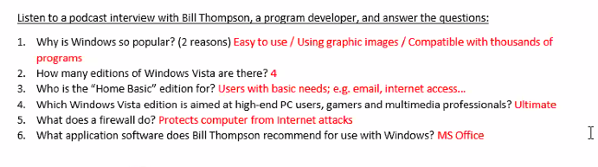



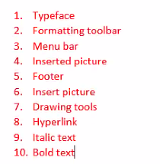

|  |
| --- |
| Language: Articles |

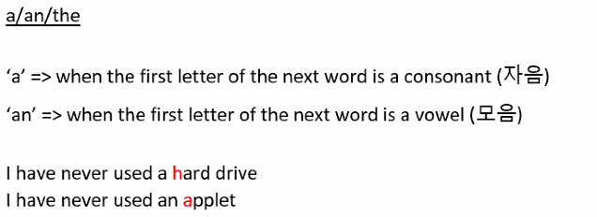

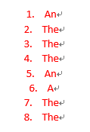

Word Processing

Label the features from Microsoft Word:

|  |
| --- |
| **bold text** / *italic text* / header / footer / inserted picture / menu bar / typeface /  hyperlink / standard toolbar / formatting toolbar / drawing tools / insert picture |



Complete the sentences:

The Standard _____________ lists icons to save or print a document, spell check, etc. The _______________ Toolbar is the area for changing font, alignment, indentation, etc.

A font has three elements: _____________, type style, and type size. For example, Times New Roman bold at 10 points.

Type style means what the typeface looks like; for example, B for _________, I for __________ and U for underline.

The __________ and ___________ commands put the same text at the top and bottom of every page.

Spreadsheets

Basic Vocabulary:

|  |  |
| --- | --- |
| 1. If we divide 8 by 2, we get C 2. If we subtract 2 from 8, we get B 3. If we multiply 8 by 2, we get D 4. The sum of 8 and 2 is A | 1. 8 + 2 = 2. 8 – 2 = 3. 8 / 2 = 4. 8 x 2 = |

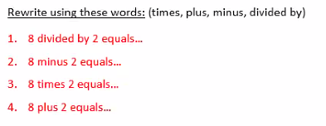



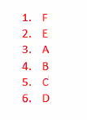

Listen to four employees and their problems with spreadsheets:

|  |  |
| --- | --- |
| **Action** | **Problem** |
| 1. |  |
| 2. |  |
| 3. |  |
| 4. |  |

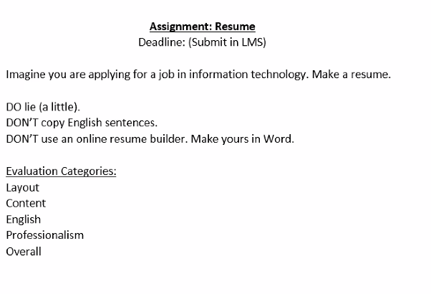

**Jobs and Duties(의무)**

Complete:

|  |  |
| --- | --- |
| 1. Maria is a __software developer_ 2. Ahmed is a __helpdesk manager ___ 3. Freddy is a ___ project manager _ | 1. Hana is a serport technician 2. Tim is a_database designer / admin 3. Sophie is a system analyst |

Complete the collocations:

|  |  |
| --- | --- |
| 1. Supervise(감독하다) a team 2. Have a problem 3. Be responsible for IT projects   (IT 프로젝트에 대한 책임감 갖기)   1. Look after all the computers 2. Install software | 1. Diagnose(진단하다) ethe problem 2. Design databases 3. Maintain(유지하다) them(관리)  * 유지관리  1. Write specifications for software   (소프트웨어 사양 작성) |

Answer the following:

1. What time does Robert arrive? 레버트는 몇시에 도착하니?

About 8:30am

1. What does he do first? 그는 처음 무엇을 하니?

Email check

1. What is an example of a problem Robert might have with sales people?

로버트가 판매원들에게 가지고 있을 수 있는 문제의 예는 무엇인가?

Laptop

1. How does he solve the problem? 그는 그 문제를 어떻게 해결하니?

By phone or remote access

1. Who does Robert have meetings with? 레버트는 누구와 미팅을 하니?

Managers

Grammar: Adverbs of Frequency

List all the adverbs of frequency you hear: 당신이 듣는 모든 빈도 부사를 나열하시오:

|  |  |
| --- | --- |
| 1. Every day 2. Generally (일반적으로) 3. Usually (보통) 4. Normally (평소에는) | 1. Occasionally (가끔) 2. From time to time (가끔) 3. A few times every year (매년 몇 번) 4. Hardly ever (거의 없다) |

Every day, I check my emails when I get to work.

I check my emails when I get to work every day.

I Every day check my emails when I get to work (x)

Generally, I watch TV when I get home from work.

I generally watch TV when I get home from work

I watch TV when I get home from work Generally (x)

Speaking Activity:

Interview a classmate about a job they have had:

동창생과 면접을 통해 본 직장에 대해 다음과 같이 얘기하십시오

Questions:

1. Have you ever had a job befor? Yes, server admin
2. Where did you work? What was your job title?

I worked for a server company. It was a employee.

1. What were your responsibilities? server data management.
2. What were your work hours? I worked in two shifts.
3. How long did you work there? 1 year
4. What was the best/worst thing about working there? It was hard to handle the data.

1. 직업을 가진 적이 있는가?   
2. 어디서 일하셨나요? 직책이 뭐였죠?  
3. 당신의 책임은 무엇이었습니까?  
4. 근무시간이 어떻게 되셨어요?  
5. 거기서 얼마나 일했니?  
6. 그곳에서 일하면서 가장 힘들었던/최악의 일은 무엇이었습니까?

Reading:



Find words that match the definitions:

1. A company that sells things (Futachiba) provider, supplier

물건을 파는 회사

1. A company that makes things to sell (Futachiba) manufacturer

팔 물건을 만드는 회사

1. Factories (Futachiba) production facilities
2. Things a company sells (Futachiba) products

회사가 파는 물건

1. Using software that runs and stores information on the internet (IBGroup) cloud computing

인터넷에서 정보를 실행하고 저장하는 소프트웨어 사용

1. Customers (IBGroup) clients
2. Start selling a new product (Digital World) launch

신제품 판매 시작

Answer the Following:

Which company/companies

1. Is getting bigger? (IBGgroup) fast-growing

점점 커지고 있나?

1. Develops software? IBG / Digital World
2. Makes things in more than one country? Futachiba

한 나라 이상에서 물건을 만드는가??

1. Has a new product to launch? Digital World

신제품 출시 예정??

1. Sells software for use on the internet? IBGgroup

인터넷에서 사용하기 위해 소프트웨어를 판매한다?

Listening:

Listen to the track and fill in the gaps.



1. What does your company?
2. Who are your customers?
3. These your company

How many employees do you have? // Dose you company produce any ------- S/w?

What are your future plans?

1. What are your
2. Do you want to come

Meetings:

Vocabulary:

Chairperson: _______________________________________________________

Minutes: _______________________________________________________

Agenda: _______________________________________________________

Videoconference: _______________________________________________________

Teleconference: _______________________________________________________

Listening (Gist):

1. What is the main problem? ________________________________________

가장 큰 문제는 무엇인가?

Listening (Detailed):

1. Who is Ulrik?
2. What suggestion did Fred make? 프레드는 어떤 제안을 했는가 ________________________________________
3. What is the problem with it? 뭐가 문제야? ________________________________________
4. What was Fred’s next suggestion? 프레드의 다음 제안은 무엇이었습니까? ________________________________________
5. What is the problem with that? 그게 뭐가 문제야? ________________________________________
6. What was Ulrik’s suggestion? 울릭의 제안은 무엇이었나? ________________________________________
7. What does Ulrik have to do next? 울릭이 다음에 해야 할 일은? ________________________________________